User Guide:
Grainger PLC website integration

Version History
Version | Description of Change | Author | Date
1.0 | Grainger PLC website integration | Dillan Landsberg | 17/05/2024

Table of Contents

Overview 3
Unit details screen 3
Building details screen 4
Block details screen 4
Publish/Update Listing 5

Overview

Create a website integration through which prospective tenants will be able to see available units and new developments and to be able to register their interest by completing a webform.

Enhancements to the Unit and Building to capture new information that is required for the website

Approximately 30 unit attributes will be passed to the website listing

+- 12 fields will be added or modified in Salesforce

Enquiries submitted from the new website will result in the creation of a Lead record in Salesforce

Unit details screen
The following new fields were added to the Unit: ‘No. Active Grainger Website Listings’ field was added to the Unit to show how many active listings are currently on the Grainger website

‘Unique selling points’ are displayed when units are listed on the Grainger website

‘Unit Features’ are displayed when the unit is listed on the Grainger website and have the following options:

Unit Features picklist options

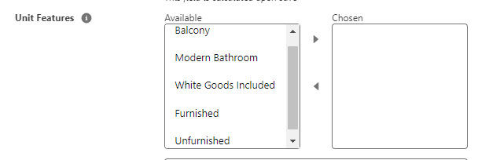

Building details screen
A new 'Building Features' field has been added to the building, the value of this field is mapped on to the Unit (Amenities) and is displayed as 'features' for units listed on the Grainger website

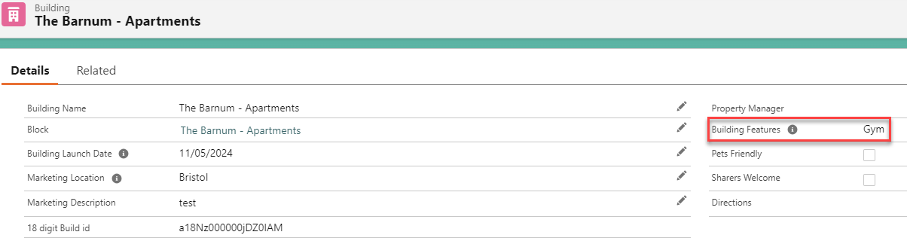

Block details screen

A new field 'Rental Type' has been added to the Block to indicate whether a property is Build to Rent (BTR) or Private Rented Sector (PRS)

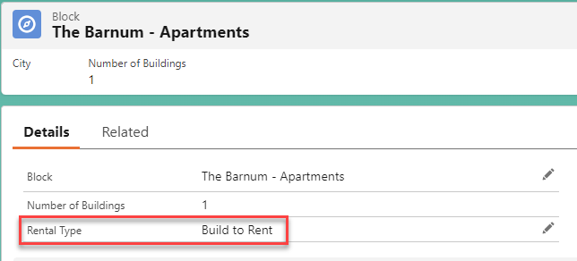

Publish/Update Listing
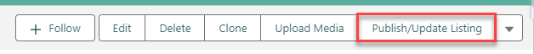This button on the Unit will load a screen that gives the option to publish, update or remove a listing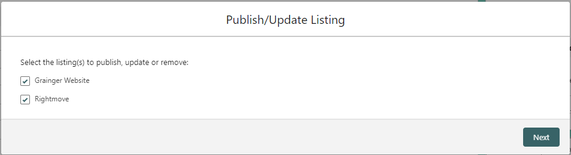
You will have a choice of Grainger Website or Rightmove listing to update or remove, if both are selected the Grainger listing will appear first followed by the Rightmove listing.

